Netting algorithm simulation

## Simulation Parameters

Simulation data are mostly based on the RTGS synthetics dataset MAS has shared in the GitHub repo.

* **Initial balance minimal**: 0.8 Millions SGD
* **Initial balance variability**: 0.6 Millions SGD. Together with starting balance, these two parameters defines how the simulator randomise initial balance. The range is 0.8 ~ 1.4 Million SGD
* **Number of accounts**: 64. According to the current MEPS+ system.
* **Gridlock resolution trigger time**: every 30mins. According to the current MEPS+ system.
* **Transaction volume**: 2,500 transactions every 30mins, which is 40,000 transactions per day, according to the synthetic data.
* **Transaction size**: here synthetic data is quite strange. We have a number of very large transaction (largest one is 9 billions, and dozens around 5 millions), while the bulk of the transaction (~30k out of the total 40k) has amount between 1000 to 10000. If we simulate with transactions range from 1000 to 10000 we will never get a grid lock situation with the above initial balance. So instead we ‘stress test’ the algorithms: the transaction size is sampled uniformly in the [0, 1e6] interval. And the transaction is between random two parties in the system.

## Evaluation Methodology

We are specifically looking at the following three groups of metrics:

* **Gridlock resolution ability**
  + number of banks in deficiency
  + Total deficient amount
* **Transaction processing ability**
  + Queue length
  + Total queued amount
* **Computational efficiency**
  + Algorithm running speed (evaluated through total time taken for 100 simulations)

## Difficulty to implement on blockchain

Basically what each of these algorithm does is for each bank in deficit, inactivate some of its outgoing payments. In considering which payment to inactivate, depending on the specific algorithm, the bank may inactivate a payment solely base on its own position (position = inflows + balance - outflows), or it may also consider whether inactivating a payment would cause the receiver of that payment to go in deficit. After some attempts to implement these algorithm in a fully decentralised fashion on blockchain, we find that communicating position information between sender and receiver will add significant complexity to the smart contract. Hence the conclusion is that if the

## Simulation Results

For each netting algorithm, 100 simulations was run at the above setting, and the statistic and sample simulation are recorded.

Section 1: Algorithm that does not requires exchange of position information

### Bilateral EAF2

**statistics**

speed 03:30

deficit_amt mean: 326.65 Mil std: 22343663.12

n_deficits mean: 29.71 std: 1.22

q_amt mean: 1117.92 Mil std: 128740595.28

q_len mean: 1756.64 std: 205.85

**sample simulation:**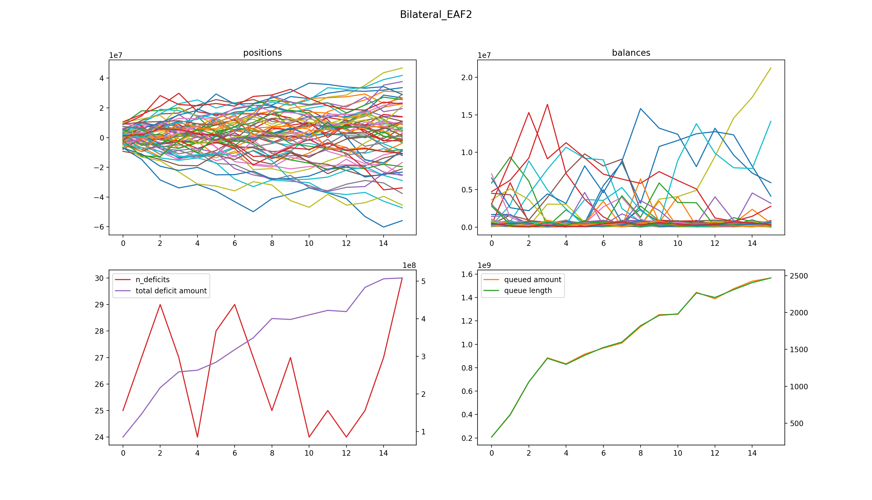

### Greedy

**statistics**

speed 14:35

deficit_amt mean: 324.80 Mil std: 24799705.53

n_deficits mean: 29.57 std: 0.96

q_amt mean: 1083.75 Mil std: 125930050.98

q_len mean: 2627.94 std: 270.39

**sample simulation:**

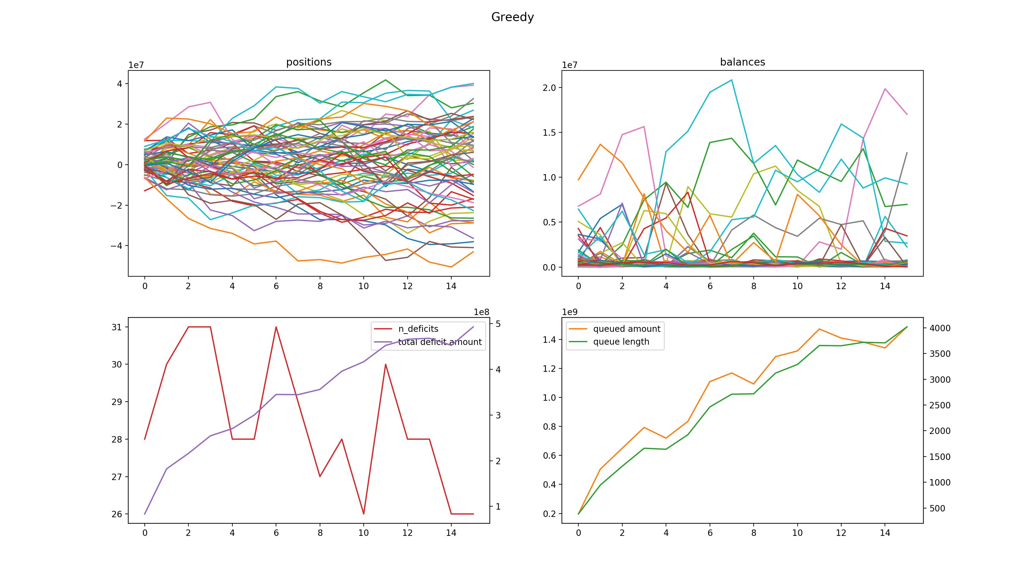

### Bouncing Greedy

**statistics**

speed 10:33

deficit_amt mean: 326.94 Mil std: 25658528.49

n_deficits mean: 29.59, std: 1.29

q_amt mean: 1081.64 Mil, std: 126300388.89

q_len mean: 1676.94 std: 200.78

**sample simulation:**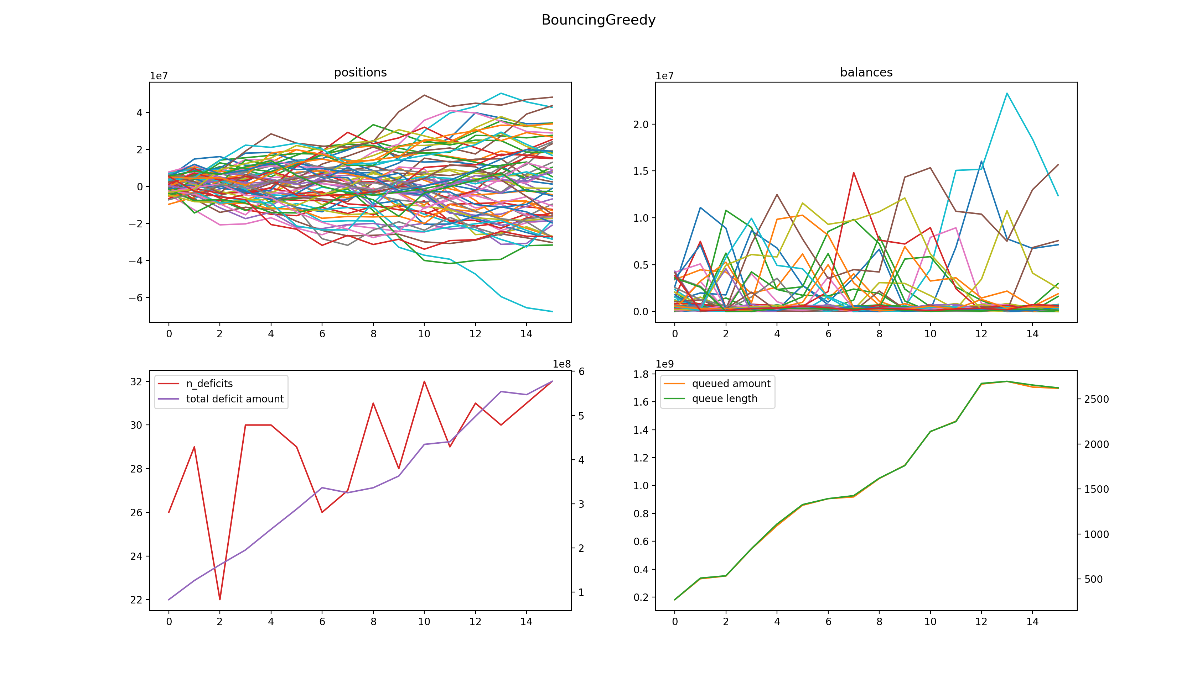

### Iterative Greedy

**statistics**

speed 24:32

deficit_amt mean: 324.37 Mil std: 24594693.72

n_deficits mean: 29.76 std: 1.22

q_amt mean: 1023.86 Mil std: 109459135.11

q_len mean: 2226.68 std: 250.98

This algorithm is significantly slower than the others, as it is effectively doing the same thing as Greedy but trying to search for inactivation set from a larger subspace within all the possible inactivation sets.

**sample simulation:**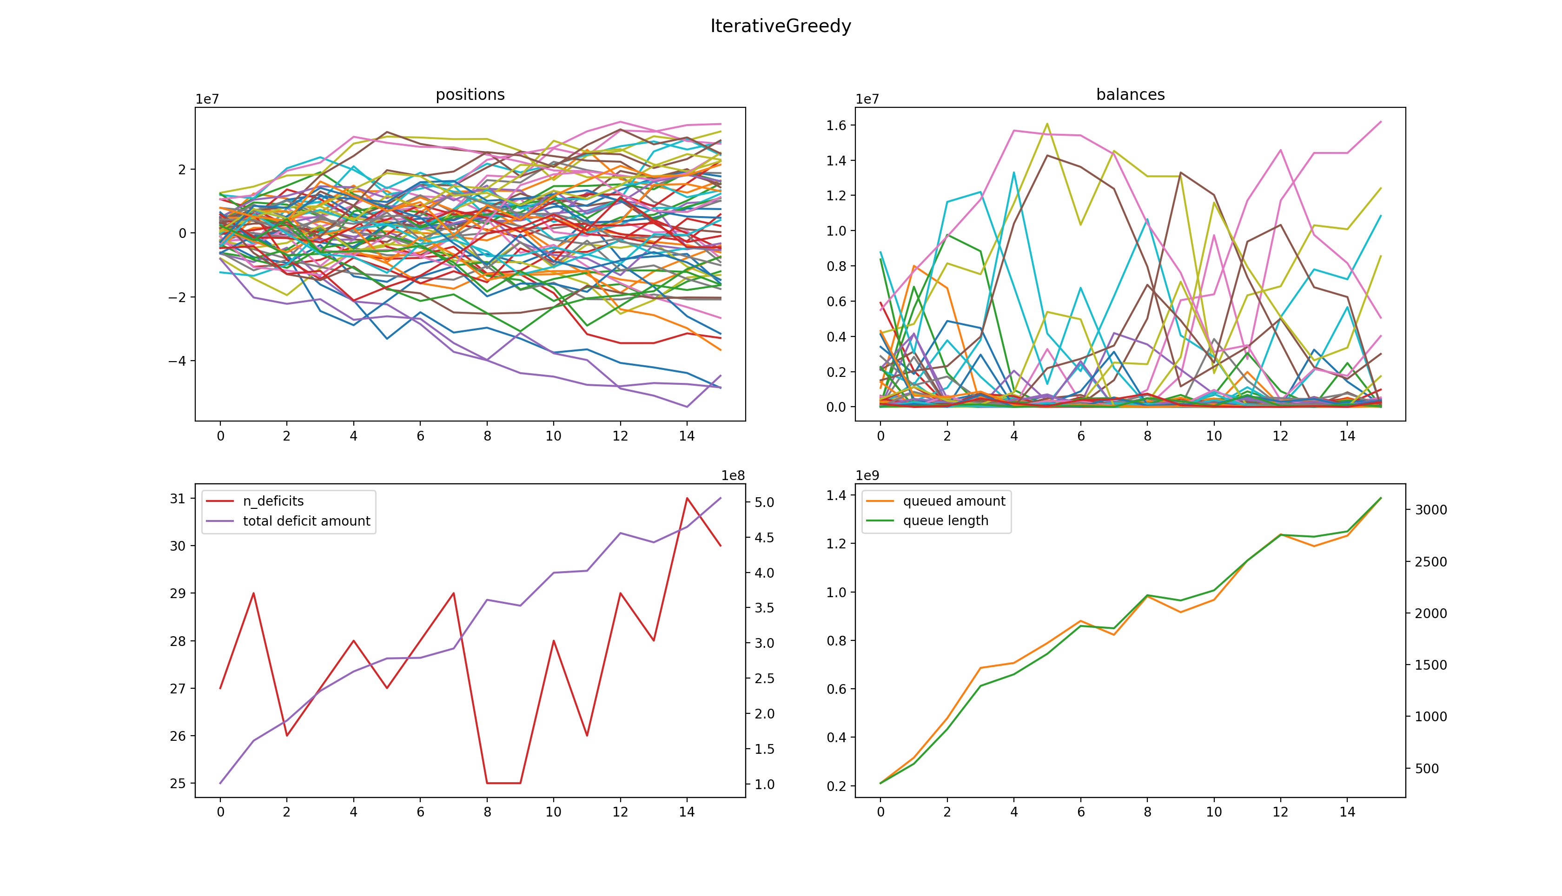

Section 2: Algorithm that requires exchange of position information

### Bilateral Inactivation

**statistics**

speed 06:02

deficit_amt mean: 328.28 Mil std: 27784404.73

n_deficits mean: 29.52 std: 1.06

q_amt mean: 481.70 Mil std: 44553634.74

q_len mean: 773.12 std: 82.63

**sample simulation:**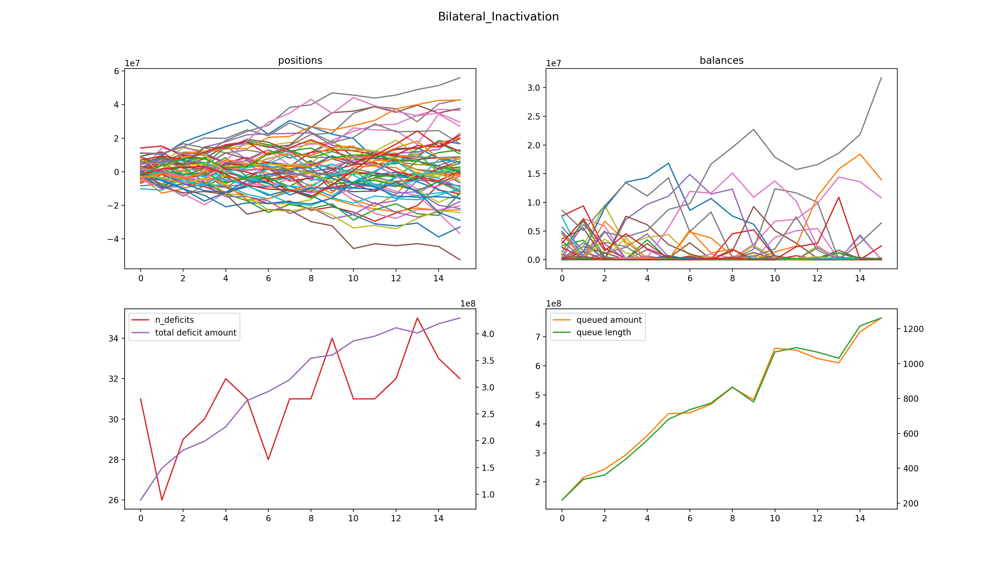

Section 2a: Algorithm that requires global sorting

In the original algorithm description for the following two algorithms (*Inactivation Run* and *Multilateral Reinactivation*), when iterating through all the deficient banks we need start from the one with largest deficit amount to the smallest. This would be difficult to implement in a blockchain system that are both decentralised and privacy-preserving. However through experiment we are confident to say that this sorting does not affect the overall performance.

### Inactivation Run

**statistics (with sorting)**

speed 00:44

deficit_amt mean: 325.09 Mil std: 29501993.81

n_deficits mean: 29.52 std: 1.10

q_amt mean: 362.31 Mil std: 31737965.52

q_len mean: 491.92 std: 42.69

**statistics (with random order)**

speed 00:48

deficit_amt mean: 327.03 Mil std: 27085534.89

n_deficits mean: 29.70 std: 1.18

q_amt mean: 379.86 Mil std: 29324047.55

q_len mean: 507.00 std: 37.98

We can see that there is really no significant difference between the two versions.

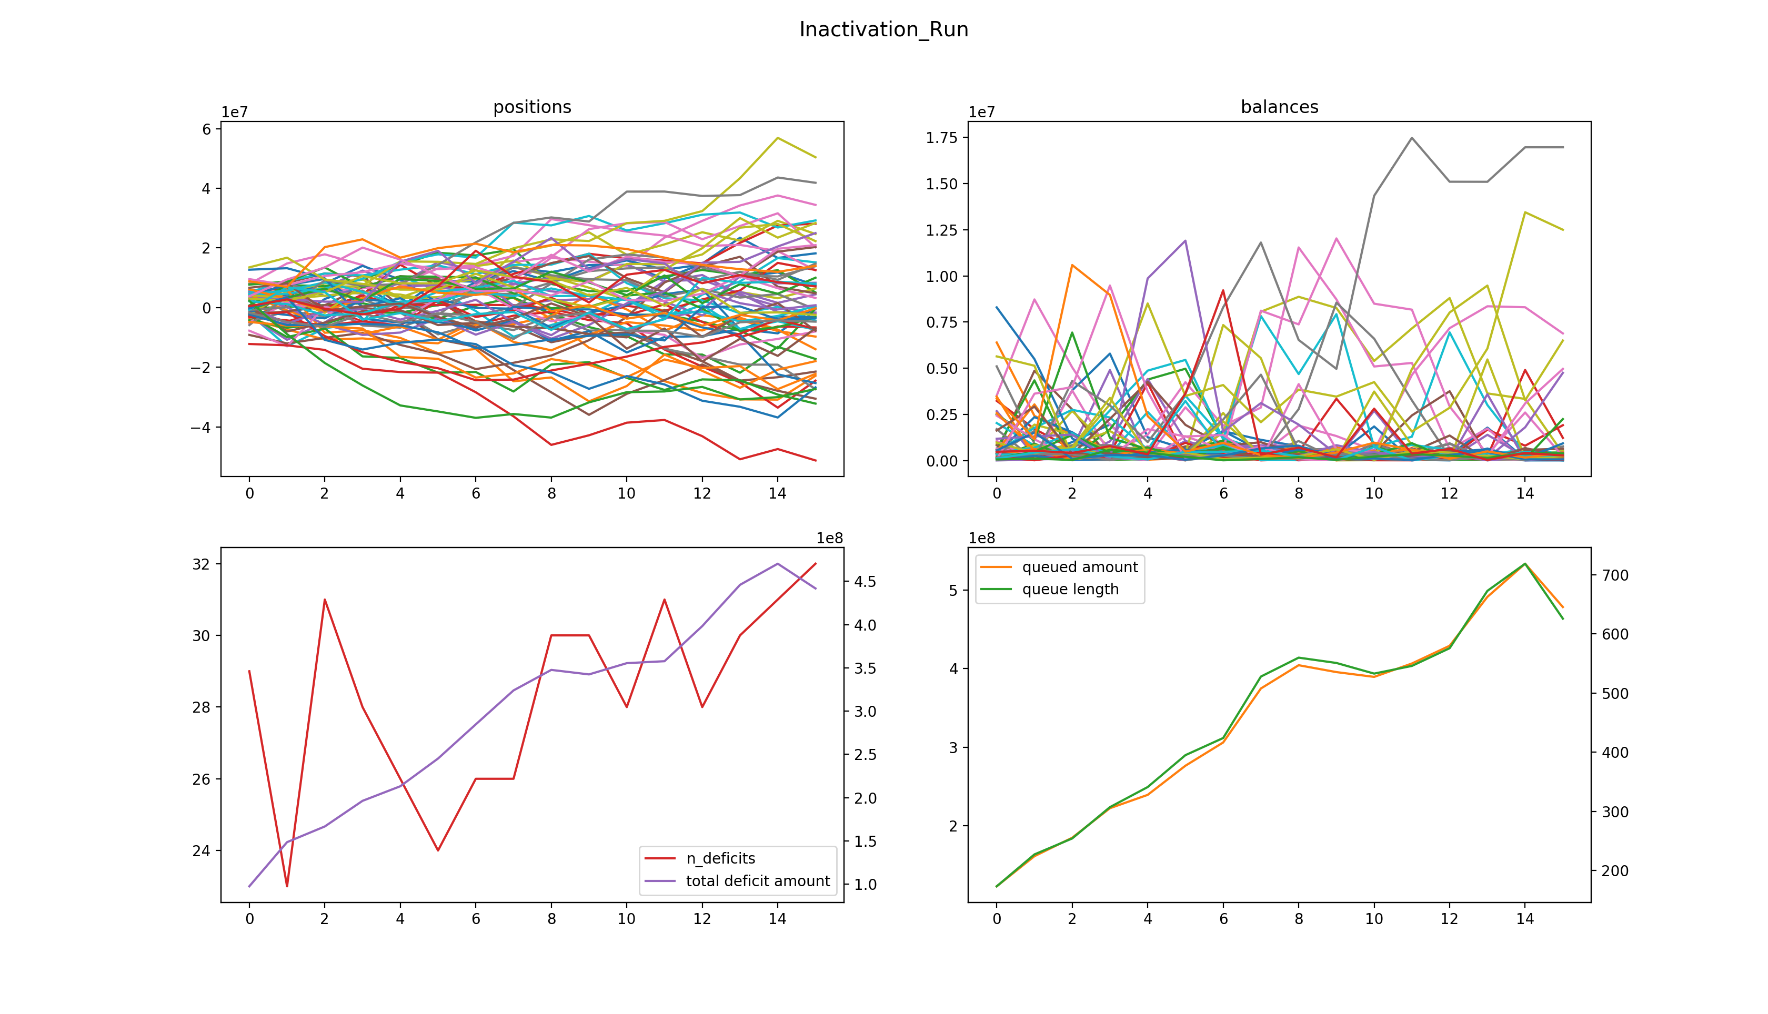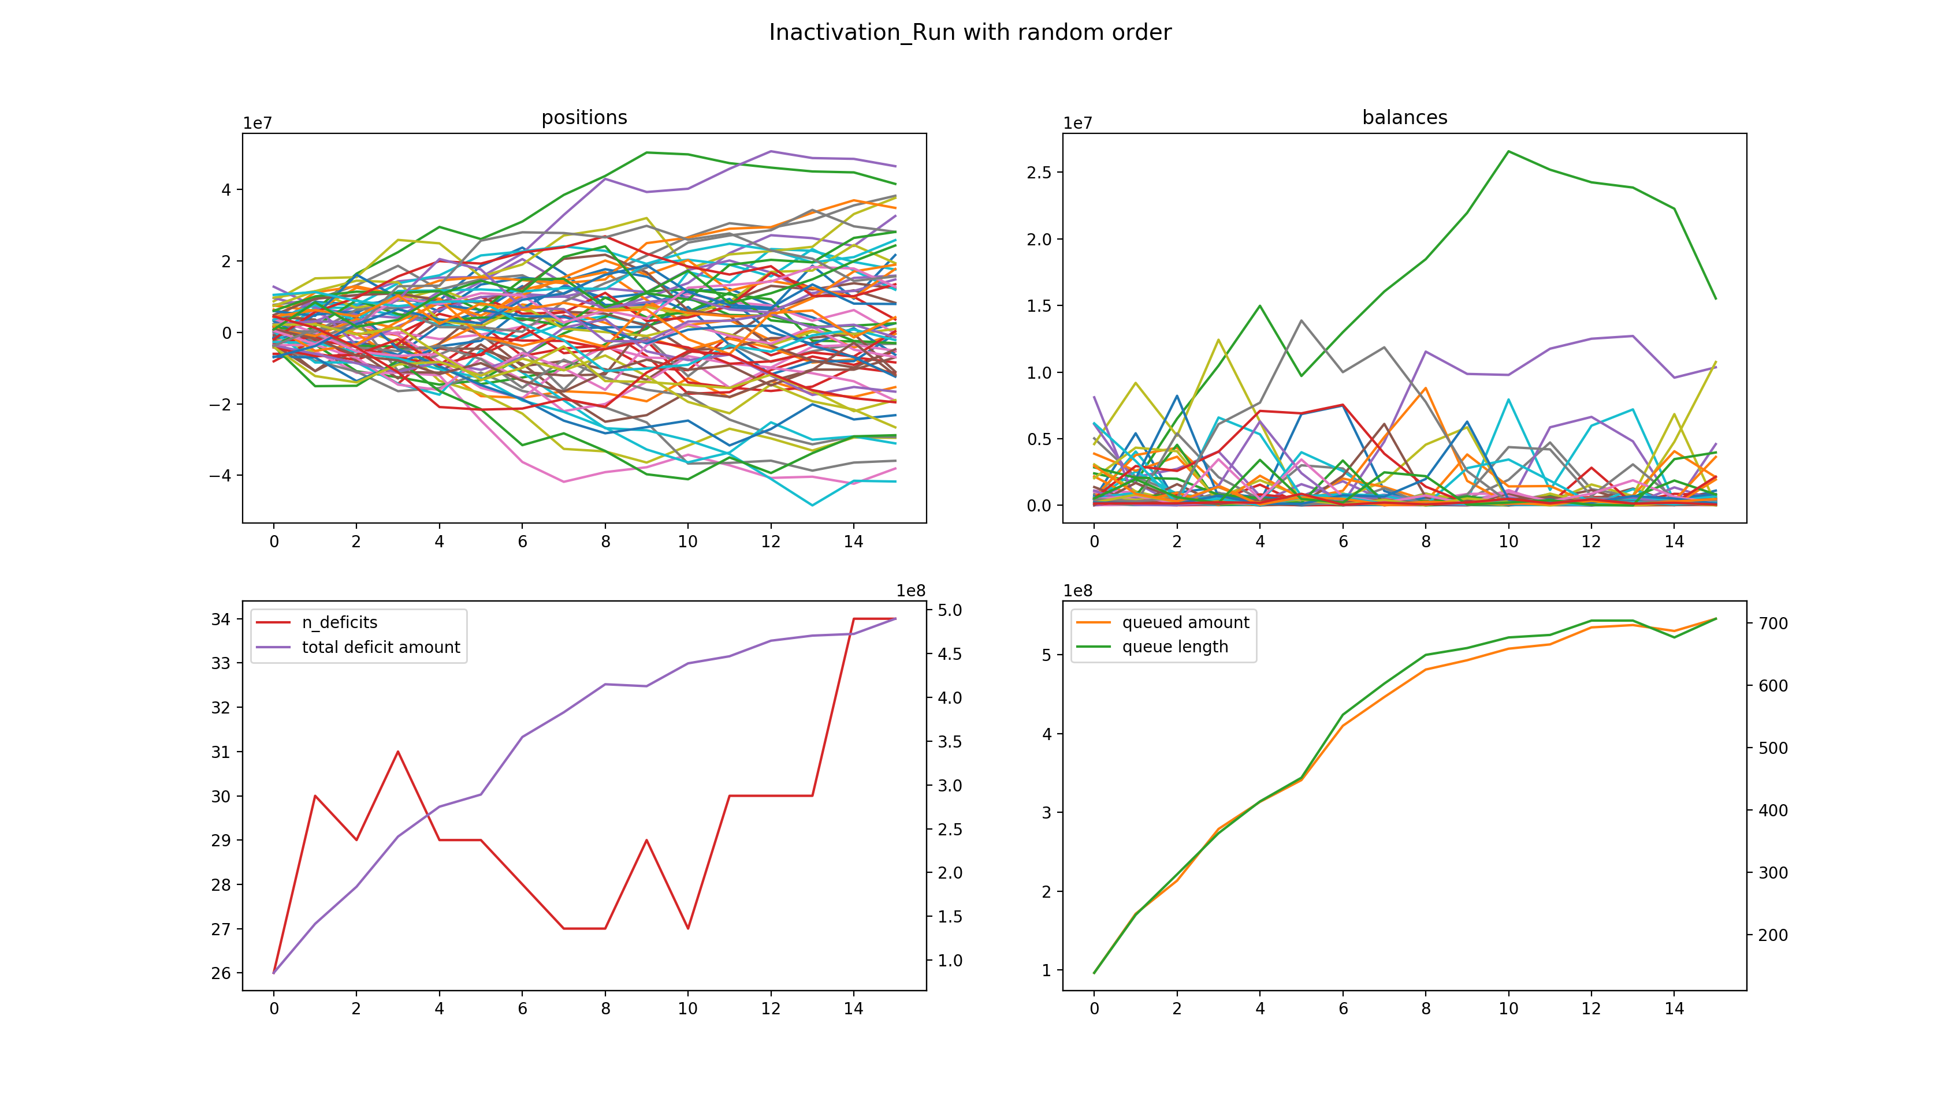

### Multilateral Reinactivation

**statistics (with sorting)**

speed 11:44

deficit_amt mean: 323.52 Mil std: 24233932.95

n_deficits mean: 29.80 std: 1.09

q_amt mean: 525.01 Mil std: 42047054.13

q_len mean: 603.95 std: 48.21

**statistics (with random order)**

speed 11:51

deficit_amt mean: 321.76 Mil std: 22688924.64

n_deficits mean: 29.67 std: 1.24

q_amt mean: 515.51 Mil std: 39690248.59

q_len mean: 595.95 std: 45.95

Again, we see that there is not significant difference between the two versions.

**sample simulation:**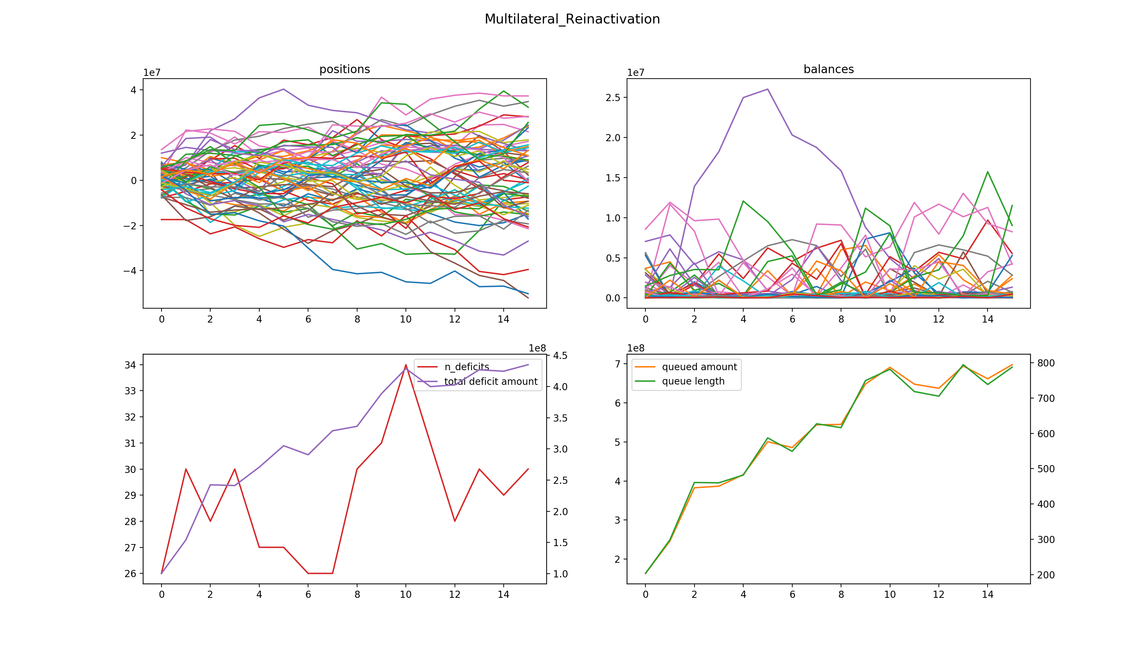

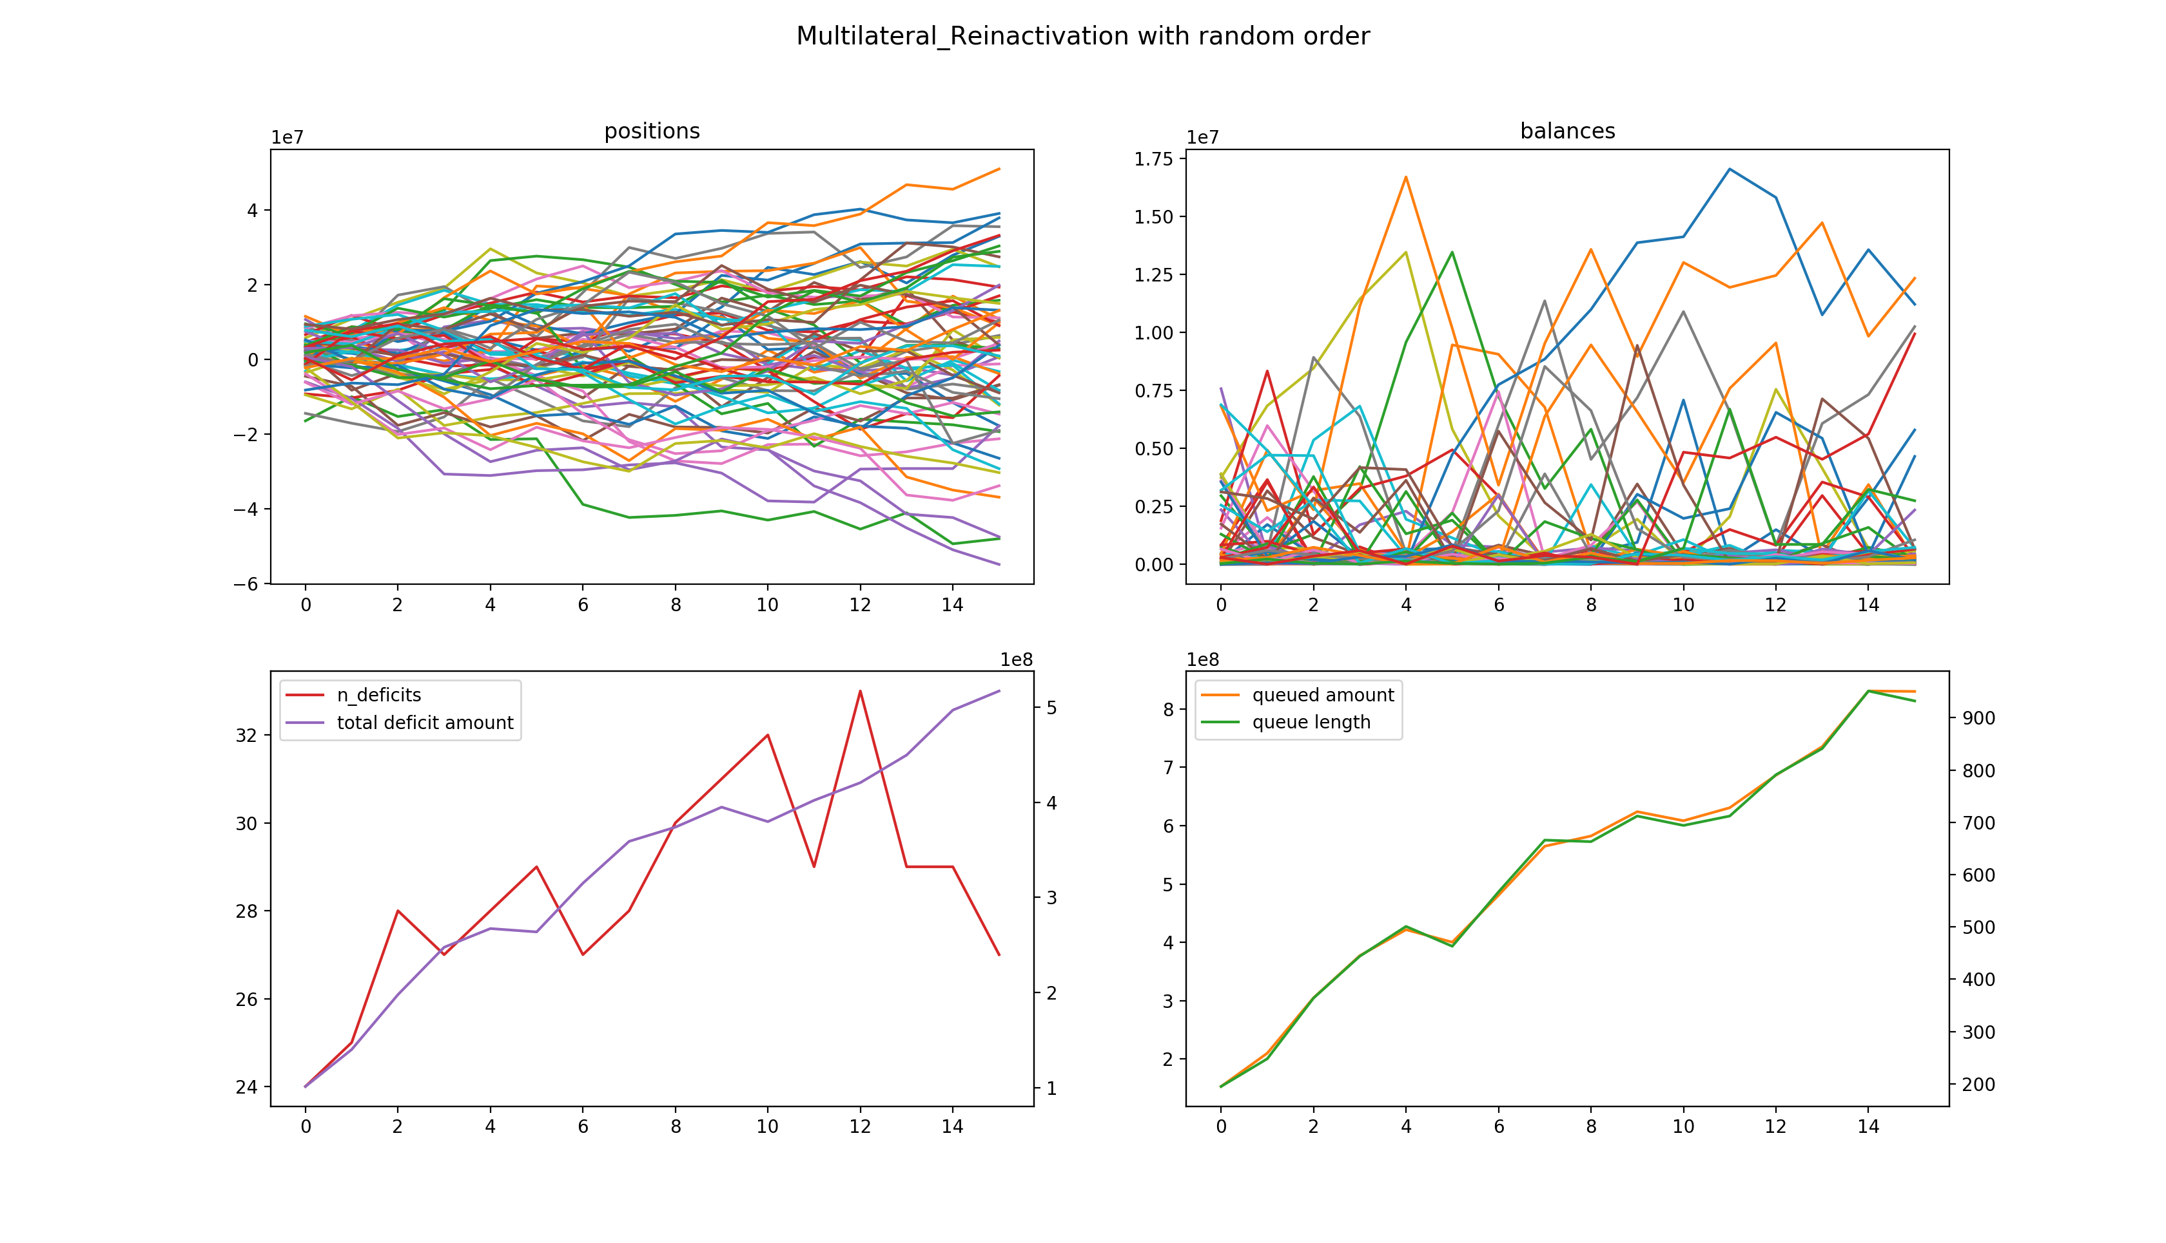

## Analysis of the Results

Surprisingly, all the algorithm performs quite similar in terms of gridlock resolution ability. Mean deficit amount is round 325 million SGD, and the number of deficient banks is around 29.75. But they differs quite a lot in terms of transaction processing ability and computational efficiency.

This is actually not unexpected. We have 64 banks with initial balances range from 0.8 to 1.4 million, and the payment sizes from 0 to 1 million.